Saving (burning) a file to a recordable CD (CD-R)

Windows XP and Windows Vista have the ability to write files saved to the hard drive of your computer to a recordable CD (CD-R). Most newer computers have a CD recordable (CDRW) or a DVD recordable (DVD/RW) drive installed.

Folders can also be written to CD-R’s. All of the files contained in the folder will be written to the CD. When writing several files to CD, though, the total amount of bytes being written cannot exceed the total amounts of bytes available on the CD-R. Typically a CD-R can hold about 700 million bytes (7000K bytes). Files can be added to a CD-R that already contains some saved files.

A file cannot be saved directly to a CD-R. The file must first be saved to the hard drive of the computer (usually in the My Documents folder) and then written (burned) to the CD-R.

To write a single file or folder that has been saved to the My Documents folder to a CD-R, follow these steps:
- Click on the Start Button at the lower left of the screen.
- Click on My Documents on the start menu.
- Right click on the file to be written to the CD.
- Move the pointer to Send To on the menu that appears.
- On the menu that then appears, click on the drive letter that represents the CDRW drive. (Usually the last drive letter in the list.
- A balloon at the lower right of the screen will appear telling you that you have files waiting to be written to CD. Click the balloon.
- On the dialog box that appears, click on “Write These Files to Disk”. The CD Writing wizard begins. First you can create a name for the CD. Then click next until the writing process begins. When the file is successfully written to the CD, the CD will be ejected from the drive. That’s the indication that the file has been written.
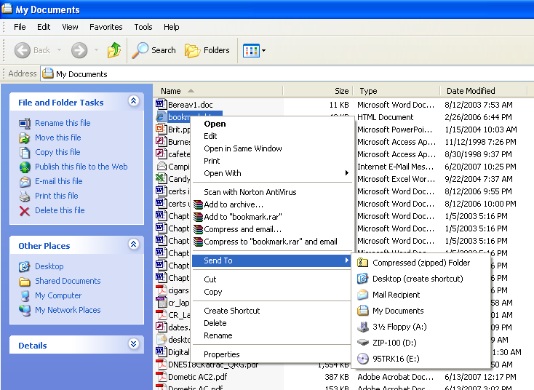

To write multiple files the process is essentially the same as writing a single file except multiple files will be selected to be written.

- To select multiple files that are consecutive in the list of files, click on the first file, hold down either Shift key on the keyboard and click the last file in the list. All files in between will be selected. With your pointer in the selected list, right click and then choose Sent To and then click on the CDRW drive.

- To select multiple files that are not consecutive in the list, hold down either CTRL key on the keyboard and click on each file to be written. Then with your pointer on any of the selected files, right click then choose Send To and then click on the CDRW drive.

