Working with the Desktop

Adding a shortcut to the desktop:
- Click the Start Button.
- Click on All Programs.
- Find the icon in the menus.
- Right click the icon, go to Send to, Click on Desktop (create shortcut).

Removing a shortcut from the Desktop:
- Right click the icon.
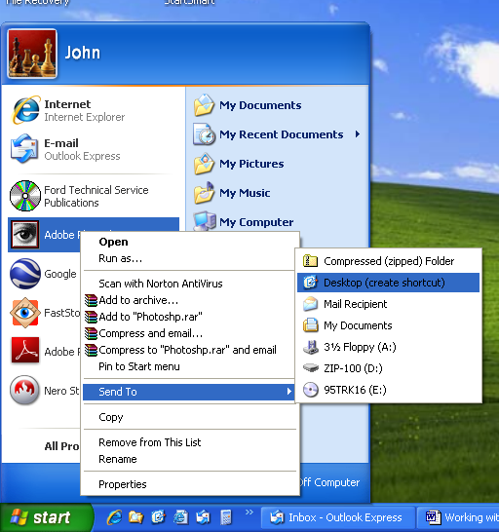
- Click on Delete. This will only remove the shortcut from the desktop. It will not remove the program from the computer or in any way interfere with the operation of the program,
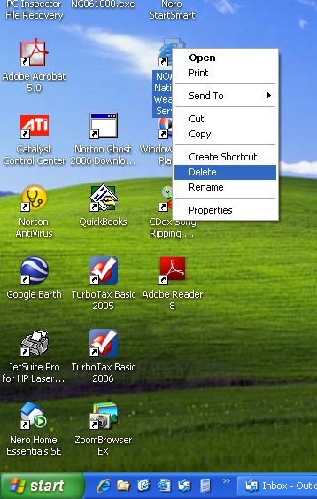

The Quick Launch Bar
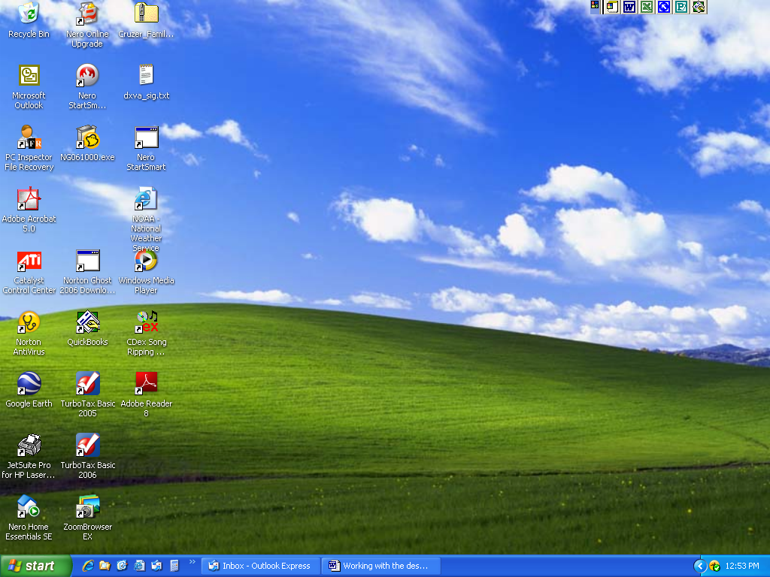
Quick Launch Bar
Taskbar

If the Quick Launch Bar is not visible, enable the Quick Launch toolbar by right clicking on the Taskbar, click on Toolbars, click on Quick Launch.

- To add an icon to the Quick Launch bar, put the pointer on the icon and drag it down to the Quick Launch Bar.

- To remove an icon from the Quick Launch bar, put the pointer on the icon and drag it up off of the Quick Launch bar.

