How to Check System Information

Do you need to know which version of Windows you are running, which service packs have been applied to Windows, what your processor speed is, or how much RAM memory is in your computer?

Do this to find out:

Click on the Start button and then right-click on My Computer. Then click on Properties. You’ll see a screen like this one:
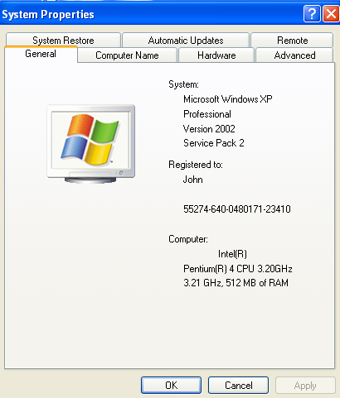

If you would like to see even more detailed information about the components of your computer, click on the Hardware tab and then click on the Device Manager tab. In Device Manager, click on the plus signs to see detailed information about each component.

Want to see what size hard drive is in the computer and see how much hard drive space you are using and how much is free?

Do this to find out:

Click on the Start button and then click on My Computer. Right-click on the icon for the hard drive (Local Disk C:) then click on Properties. A pie chart will appear showing the total amount of hard drive space and how much space is used and how much space is free.
