How To Use The Control Panel

To access the Control Panel, click Start then Control Panel.
Circled below are some of the most commonly used items in the Control Panel.
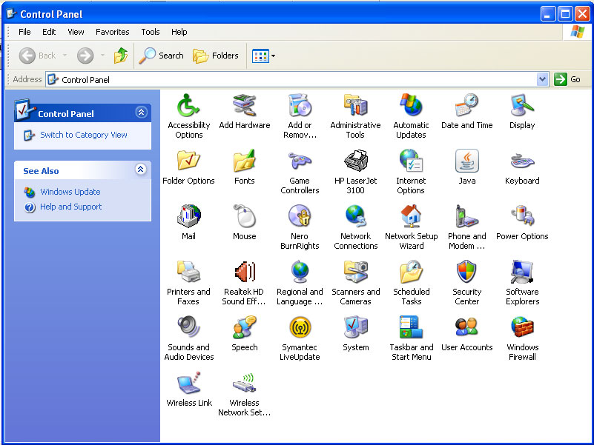

Accessibility Options - Used to change a variety of settings to make accommodations for people with visual or motor skills handicaps.

Add or Remov… (Add or Remove Programs or Windows Components). Using this item is the best way to uninstall a program from your computer.

Date and Time – Used to set the date and time as well as the time zone.

Display – Used to change the display settings. By changing the display settings you can make to content of your screen bigger or smaller.

Keyboard – used to control to key repeat rate and the blinking speed of the cursor.

Mouse – Used to change how the buttons and wheel will work on the mouse as well as how the pointer looks on the screen.

Printers and Faxes – uses to view the installed printers and to change the printers properties.

Security Center – used to control the Windows Firewall and other security settings.

Taskbar and Start Menu – used to control the behavior of the taskbar and what you see on the start menu.

